Setting up the Public Blockchain

* Create your own Goreli Ethereum API Key App with Alchemy
  + Sign in to Alchemy & Create a Goreli Ethereum App

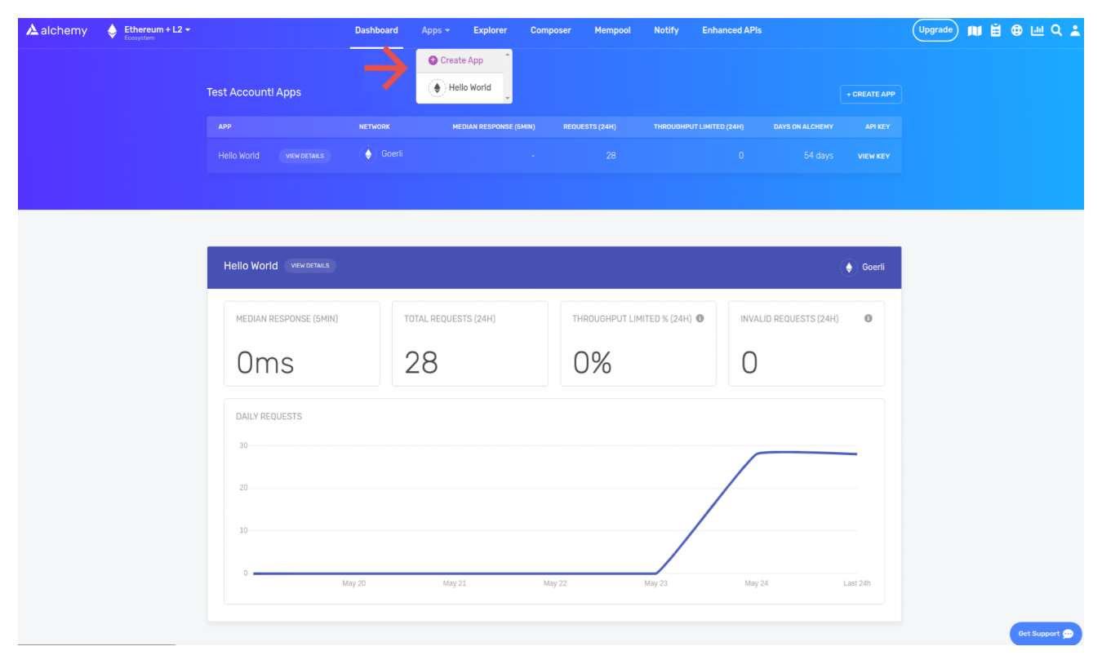

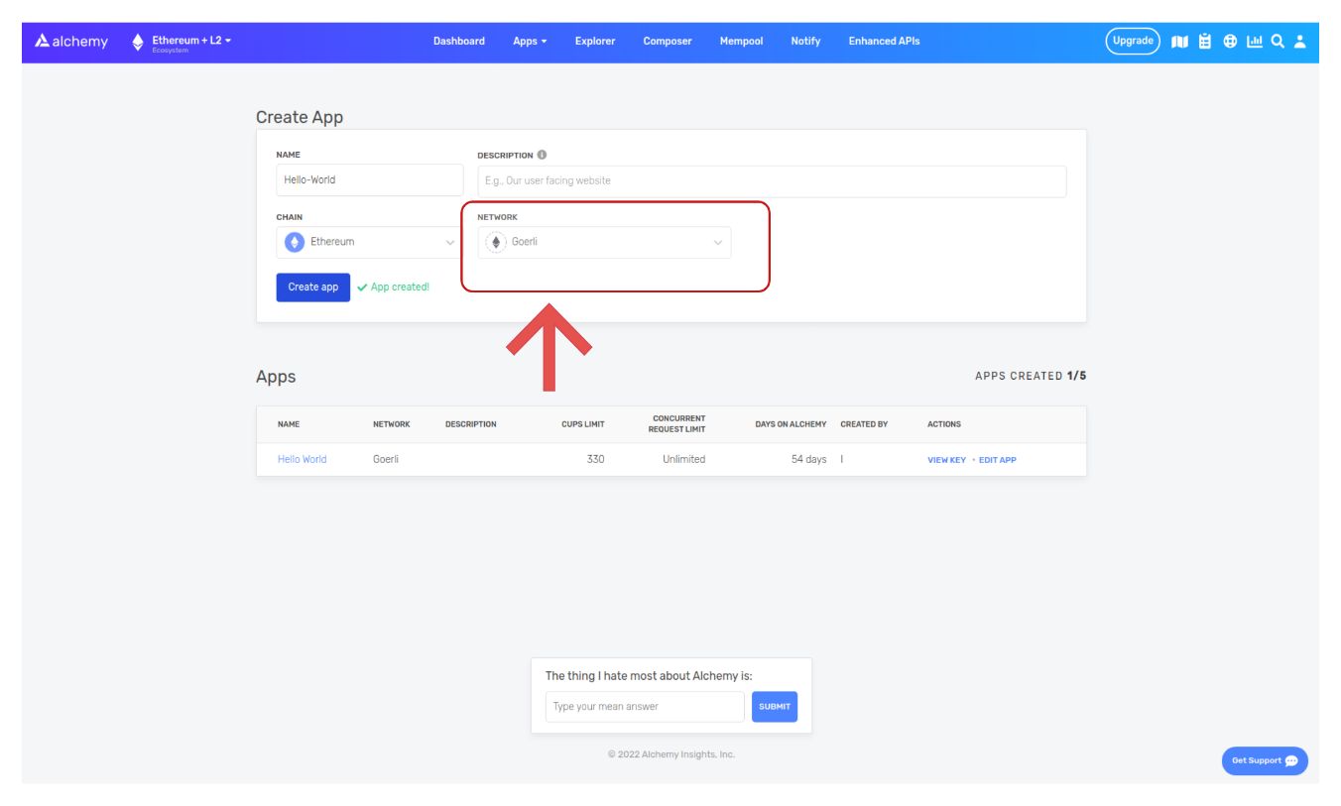

* + Grab your API Key and Follow the Installation Snippets for Javascript

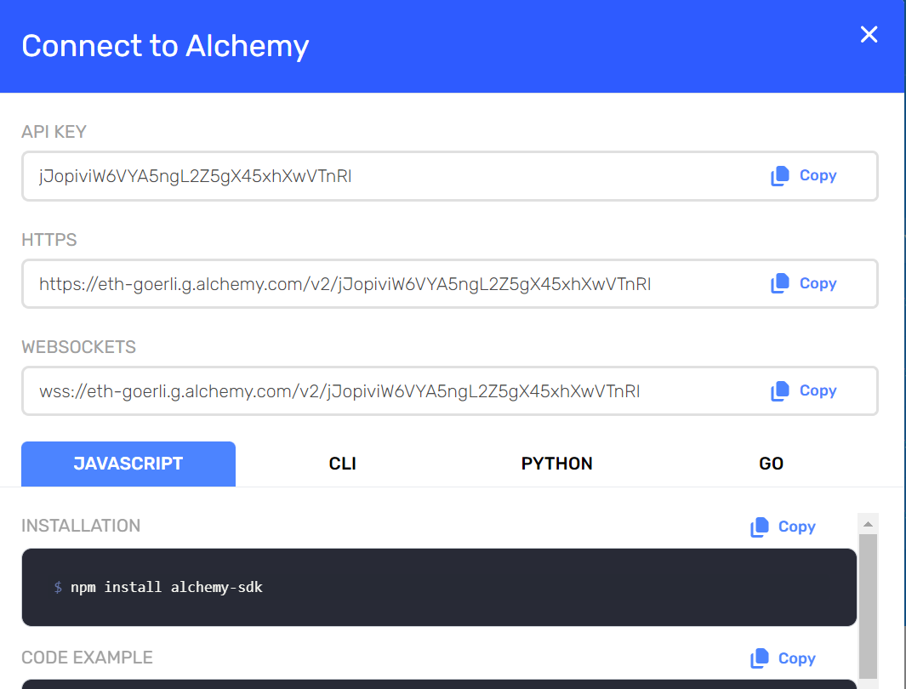

* Create your own Goreli Ethereum Account Address with Metamask and save its Private Key
  + Open Metamask and head to Goreli Test Network

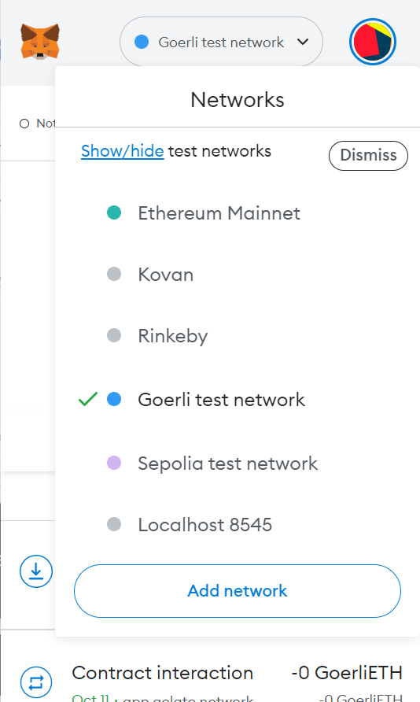

* + Click on the three dots beside the Metamask Address and click on Account Details

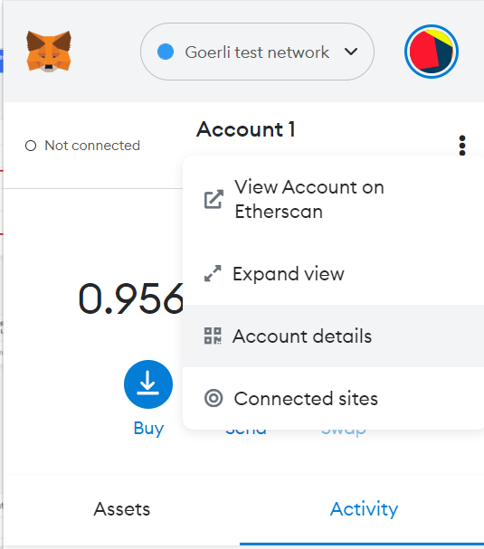

* + Export/Copy the Metamask Private Key

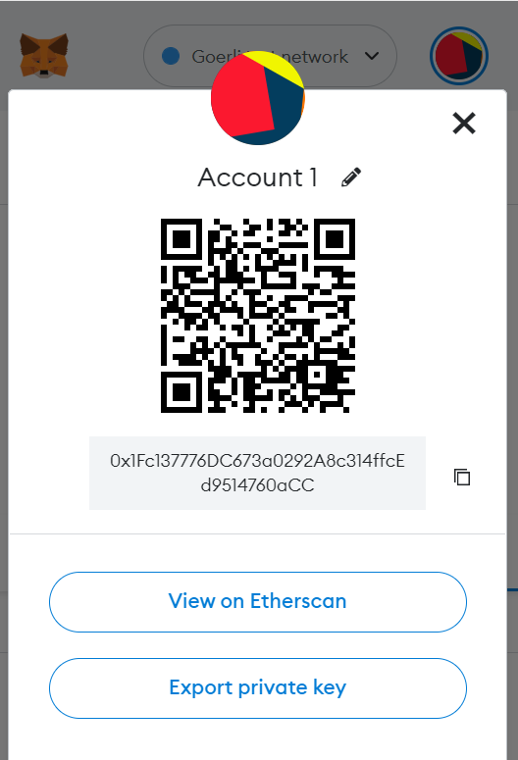

(Note: We are not using the Private Keys from the Besu Network for deployment since we do not wish to expose our Private Keys on the public blockchain)

* Add Ether from a Goreli Faucet towards the address
  + To obtain Faucet head over to this website; <https://goerlifaucet.com/>
    - Copy and Input your account address from metamask

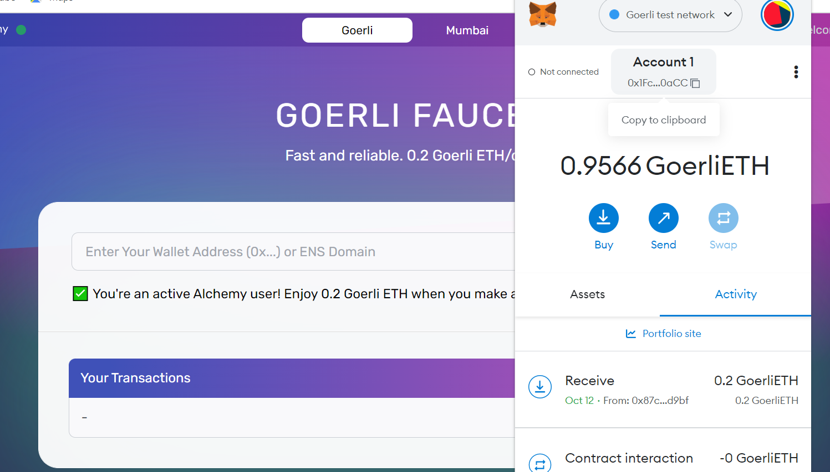

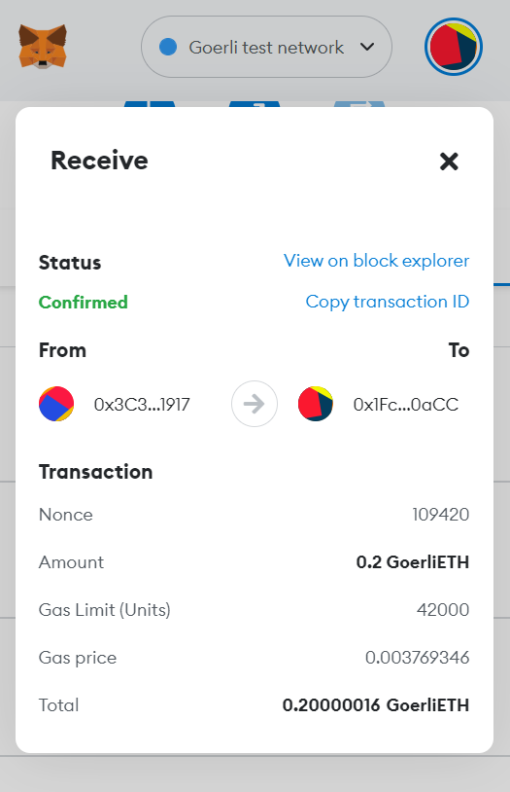

* Edit the Hardhat.config.js to include the Private Key and Alchemy HTTP API Key

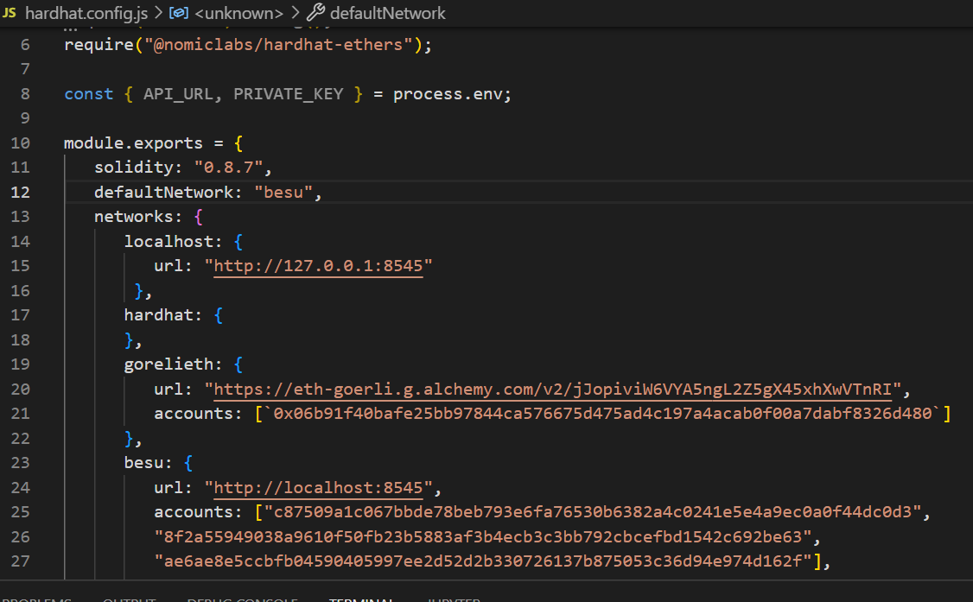

* Deploy the Test Smart Contract onto the Goreli Block Explorer using the Deploy Script, deployStorage.js.

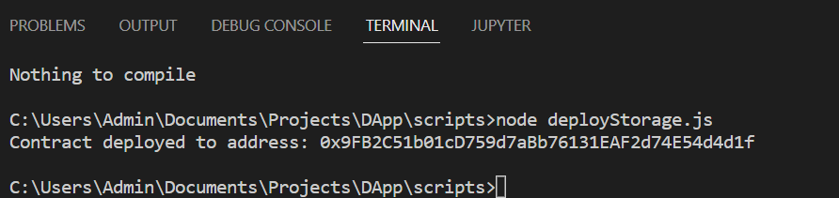

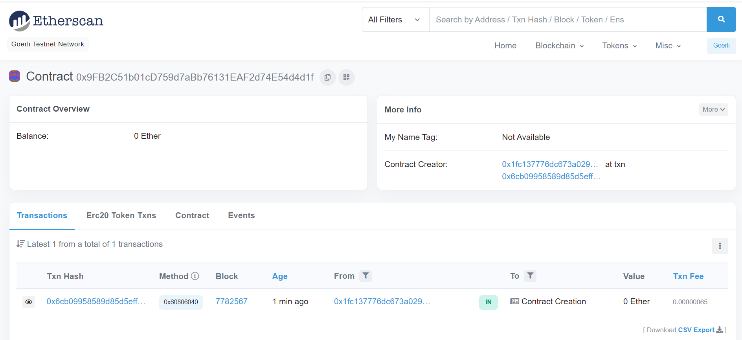

Reference Links:

<https://goerli.etherscan.io/>

<https://goerlifaucet.com/>

<https://metamask.io/>

<https://www.alchemy.com/>

<https://www.web3.university/tracks/create-a-smart-contract/deploy-your-first-smart-contract>